Link: <https://public.tableau.com/profile/smita.sharma#!/vizhome/CitiBike_SS_15628231989130/VisualTotalTrips>

I have uploaded my project CitiBike_SS on public tableau .Please find it on above link. I am also displaying the screenshots with the analysis.

1. **Total Number of Trips Recorded over a time period of 2016 Jan to 2016 Sep :102,62649**

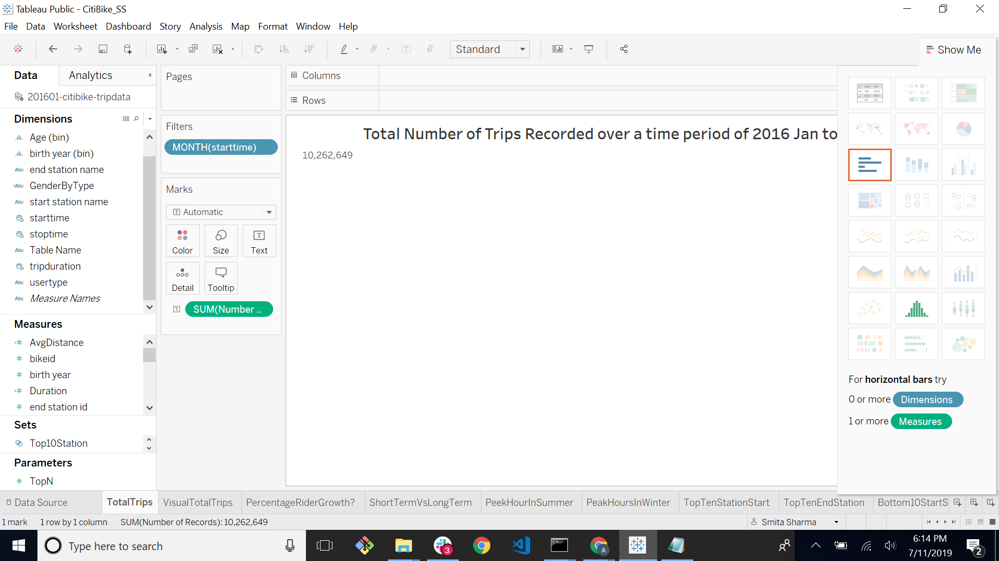

1. Visual representation of growth of total number of trips and bikers’ overtime

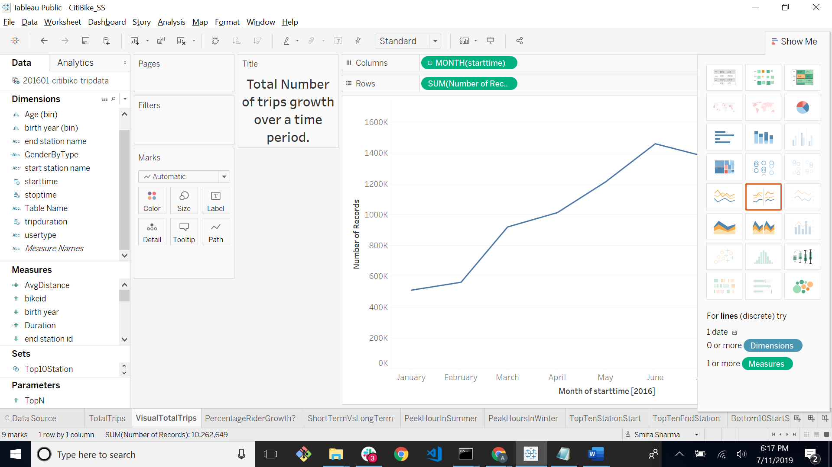

1. **Short Term Customers have less numbers of miles in comparison to the Subscribers (long term customers).**

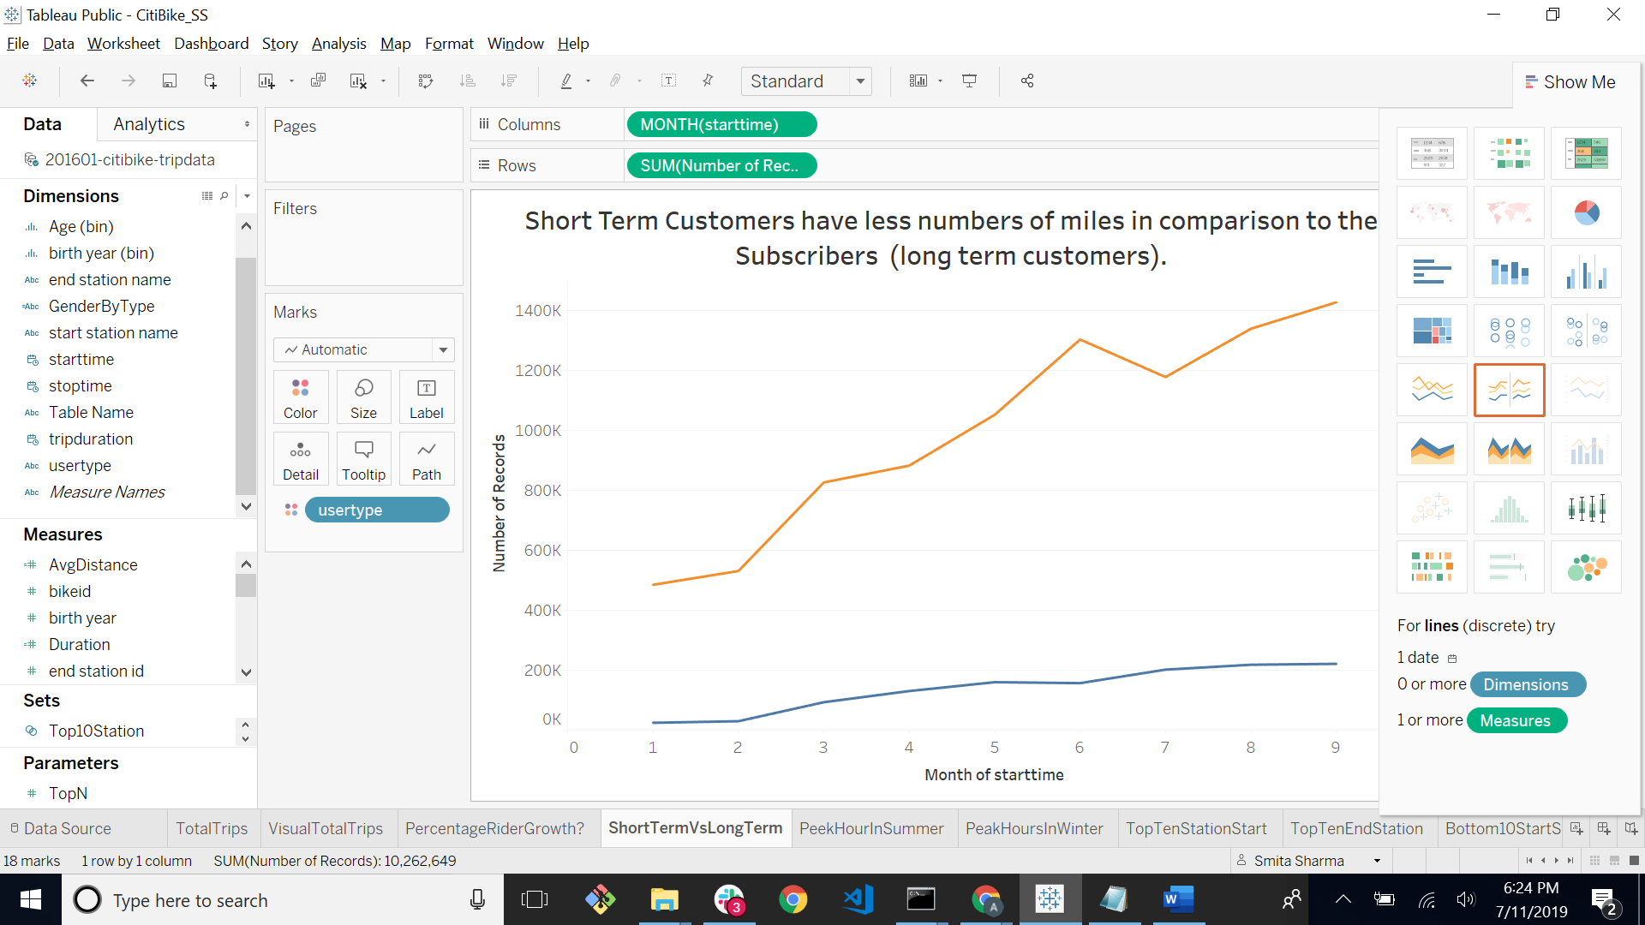

1. Peak hours in Summer time is 5pm & 6 pm

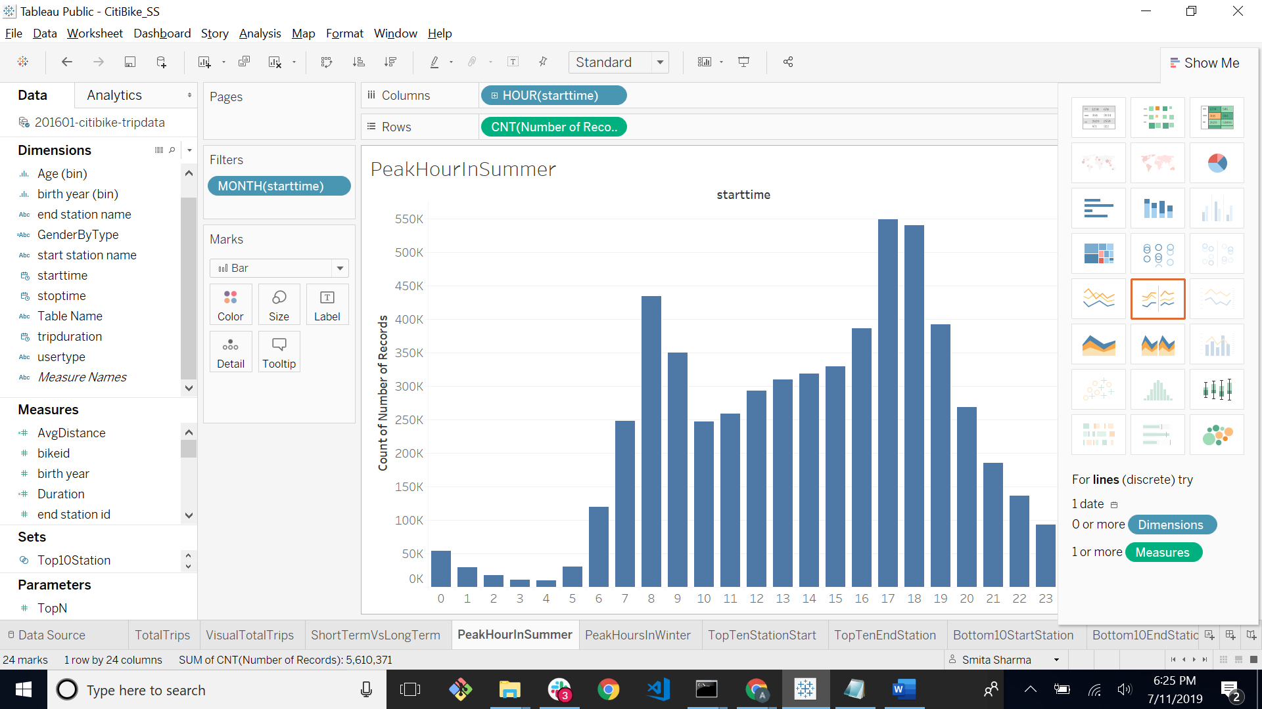

1. Peak Hours in Winter is also 5pm and 6pm

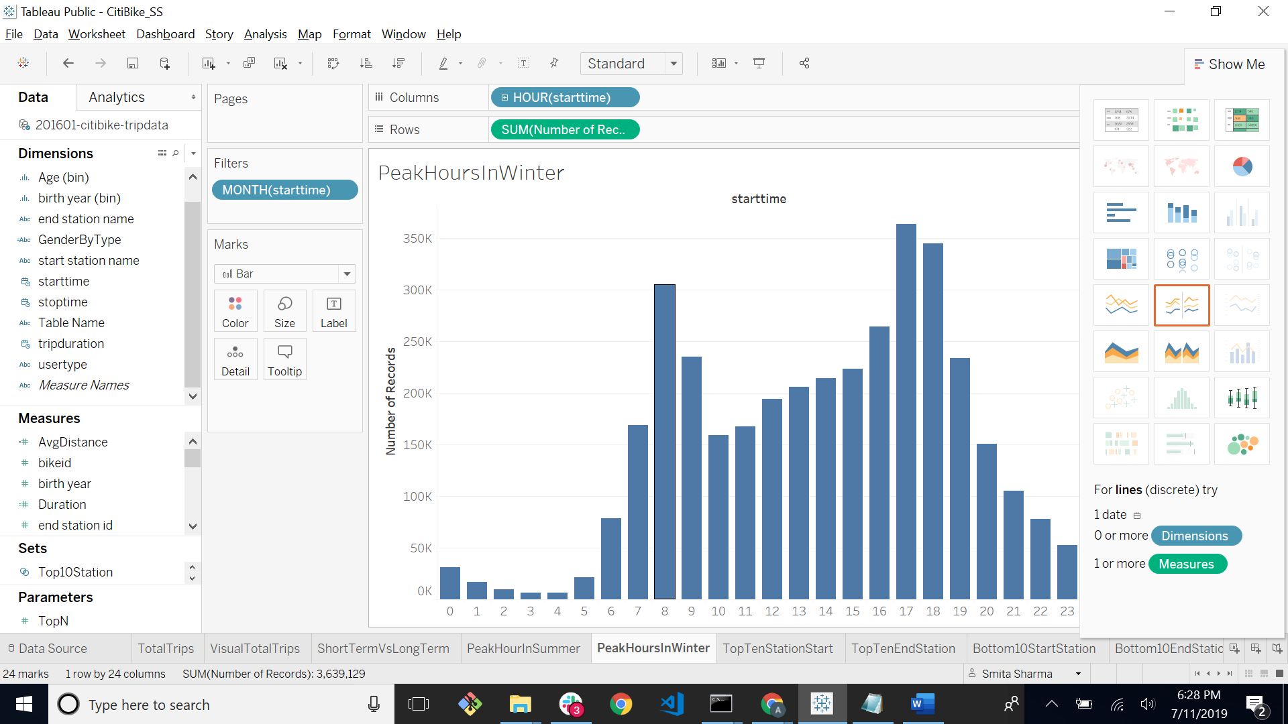

1. Top Ten Station in the city for starting a journey is in NEW YORK , NY , USA.

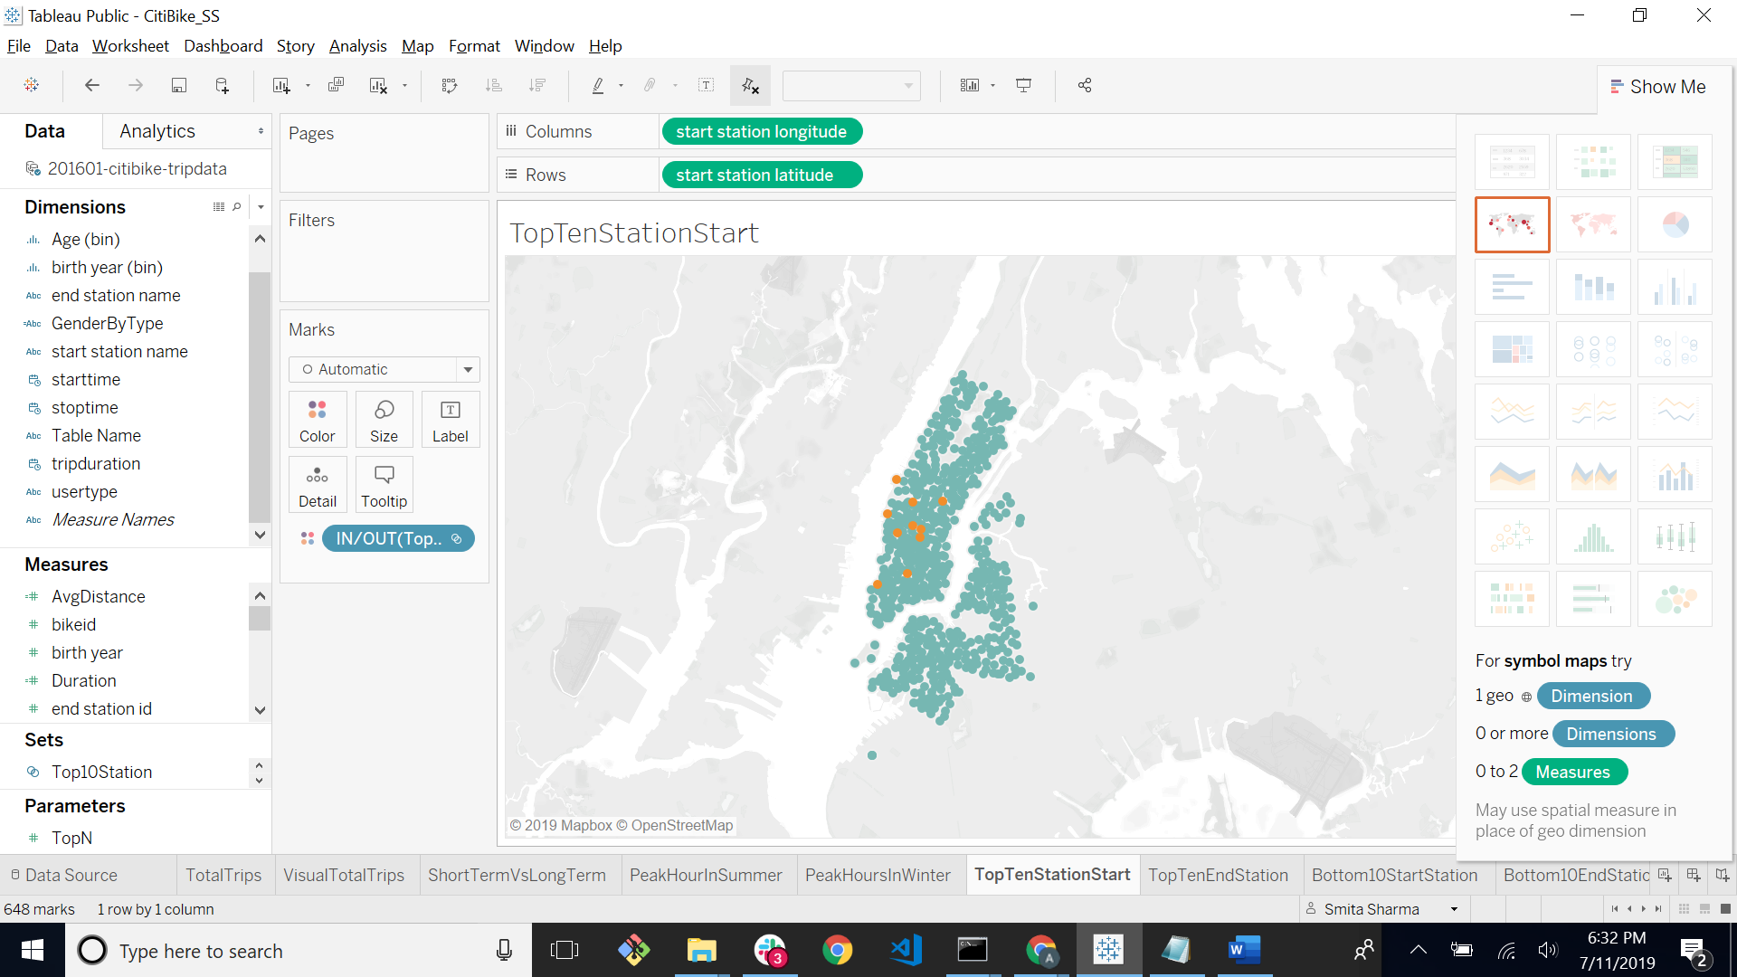

1. Top Ten Stations in the city for ending a journey is also New York, NY,USA.

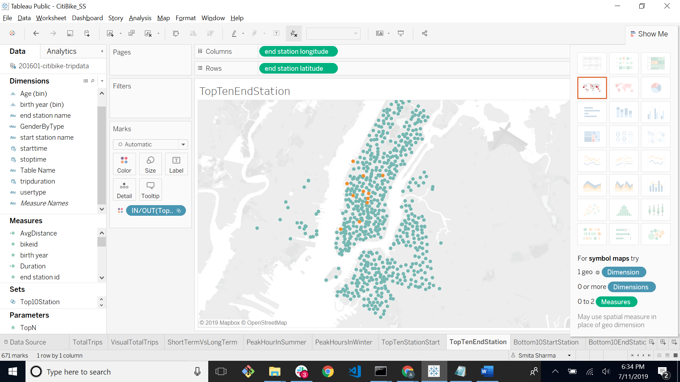

1. The bottom 10 stations in the city for starting a journey is NEW YORK ,NY USA

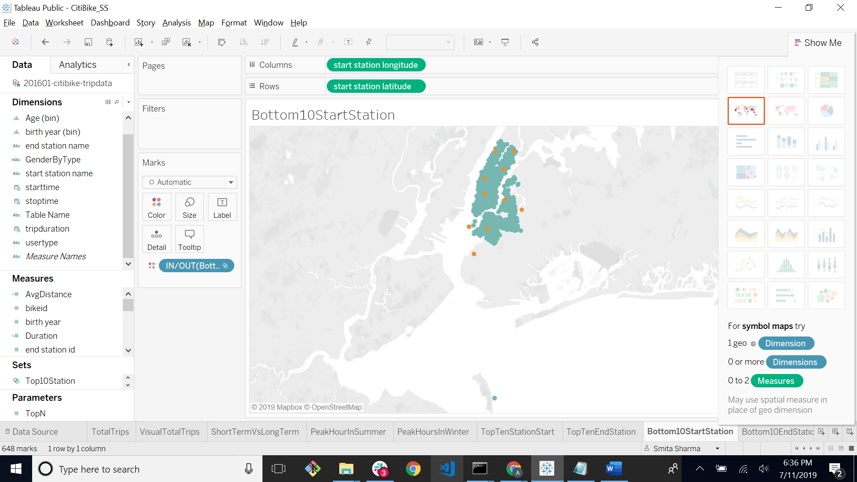

1. The bottom 10 station in the city for ending a journey is

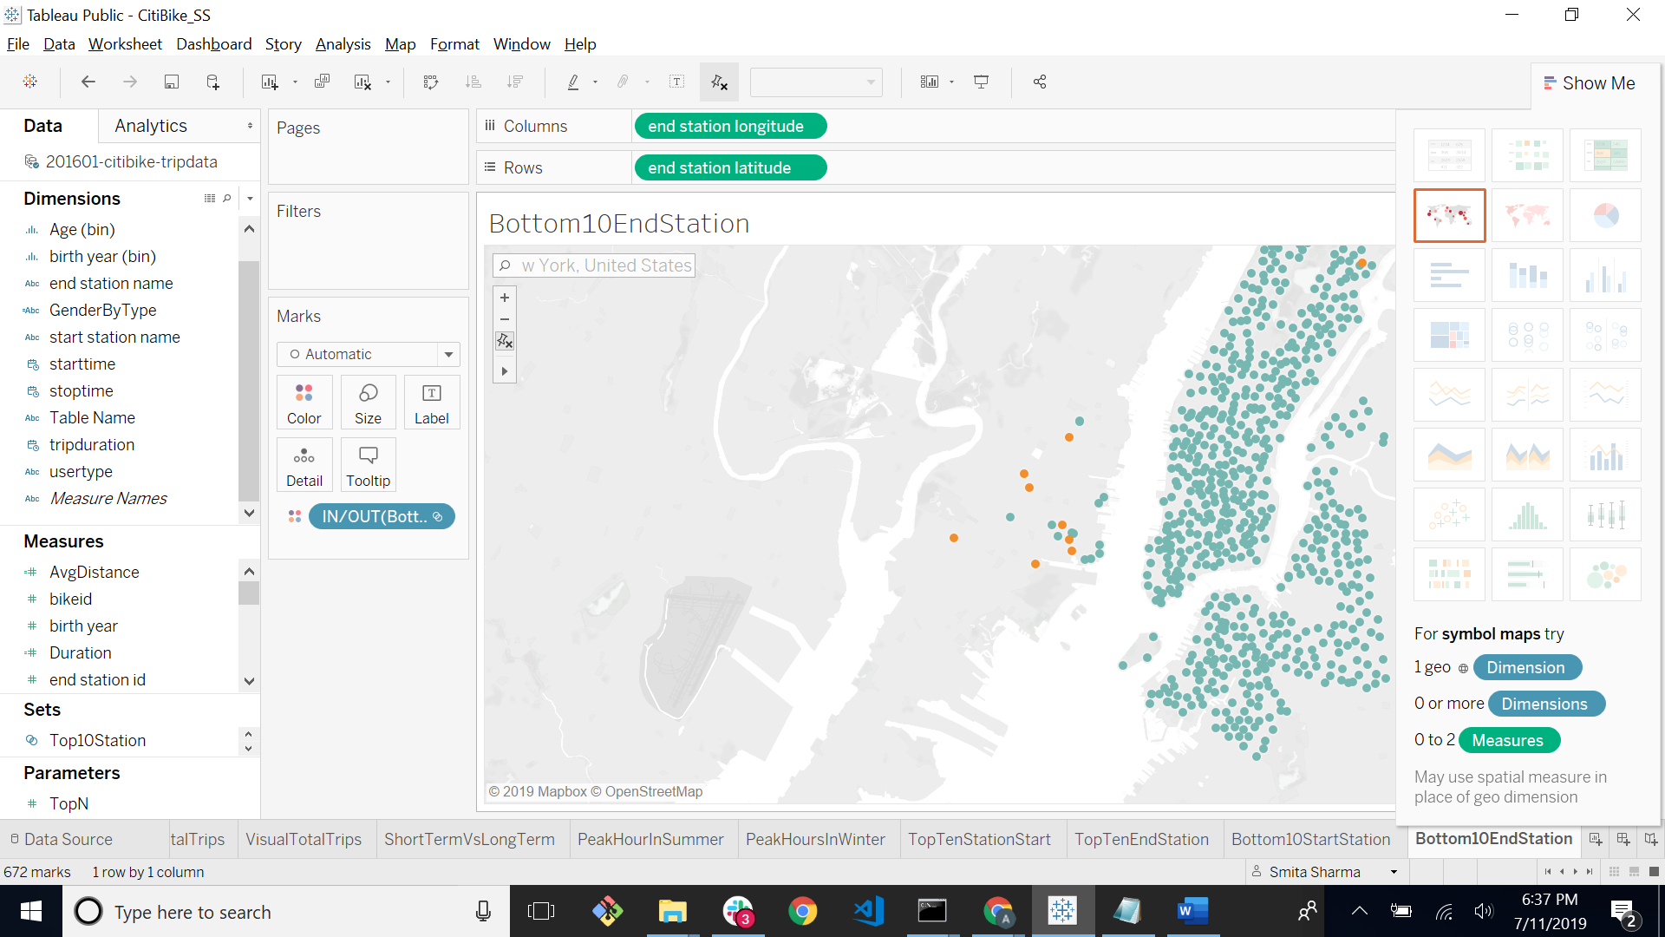

1. The gender breakdown of active participants (Male v. Female) shows Male riders are more than female riders.

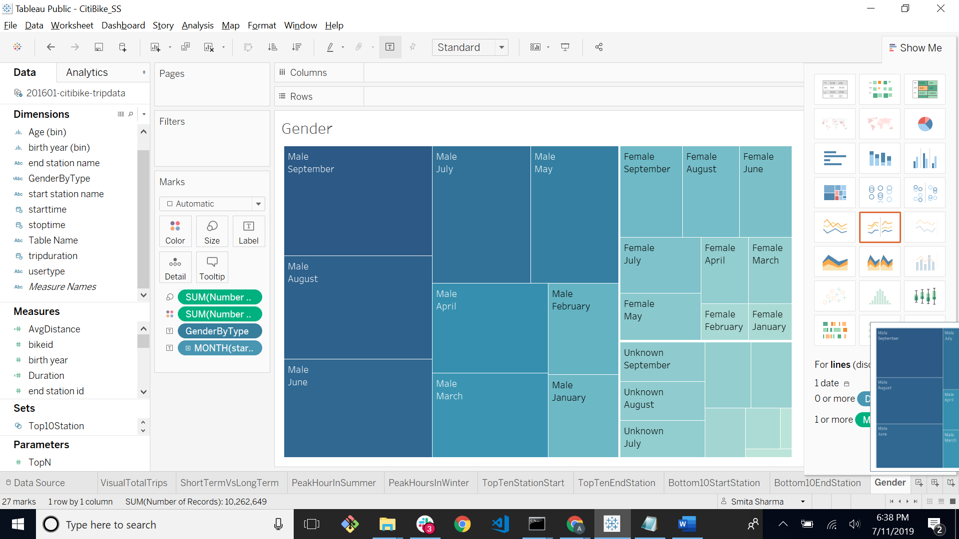

1. Female Riders are increasing over the time span hence proves it’s been an **effective initiative**. Though Male Riders are more than female riders

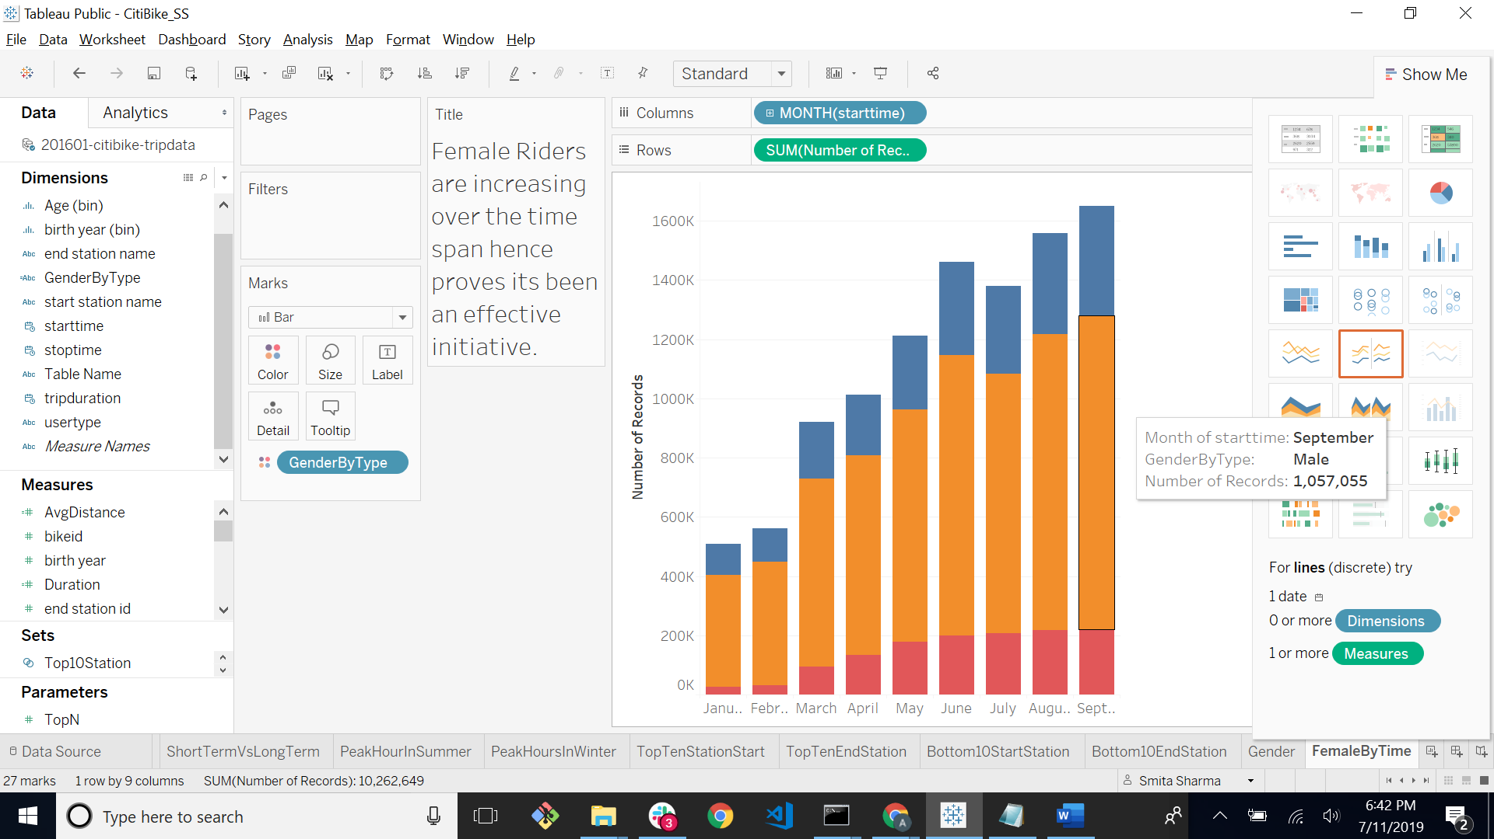

1. The average trip duration change by age is as follows. After the age of 30 the average riders riding decreases. It suggests after the prime age of 30 the riders gets lazy and switch to cars.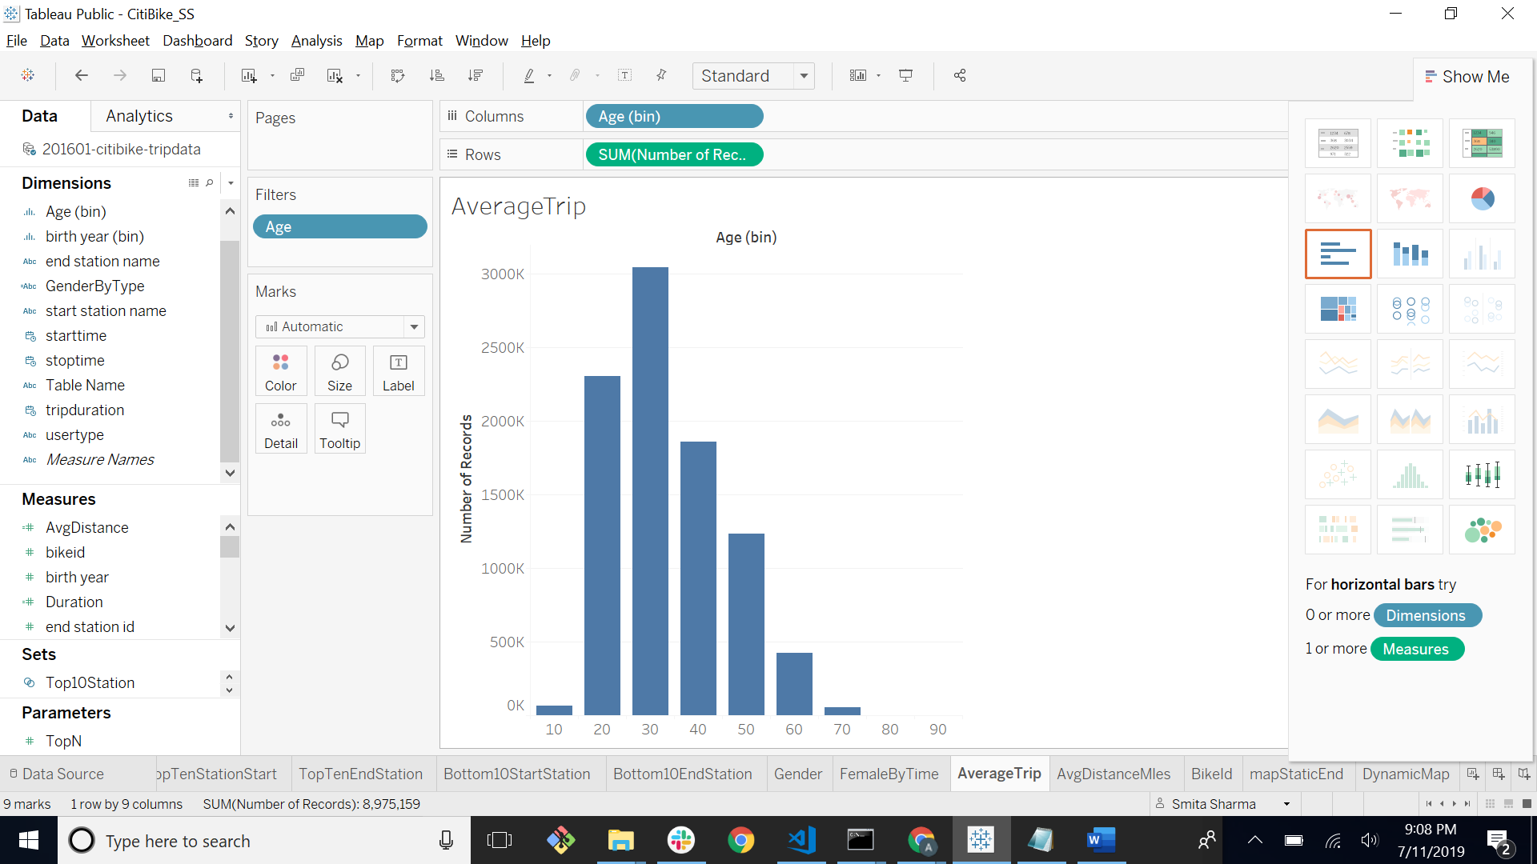
2. The average distance in miles that the riders all together gained .

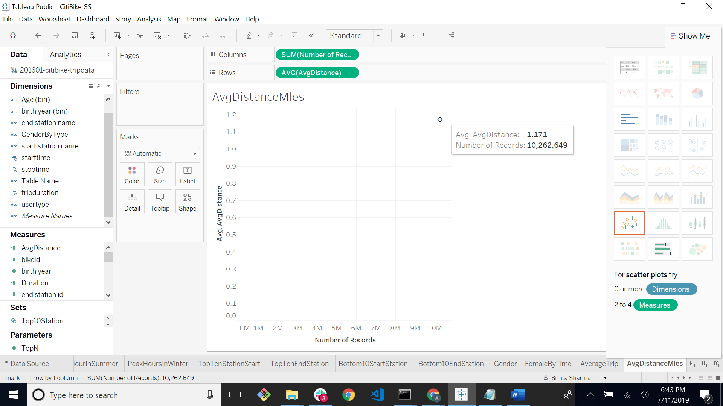

1. The bike with most trip duration is the bikes (by ID) are most likely due for repair or inspection in the timespan

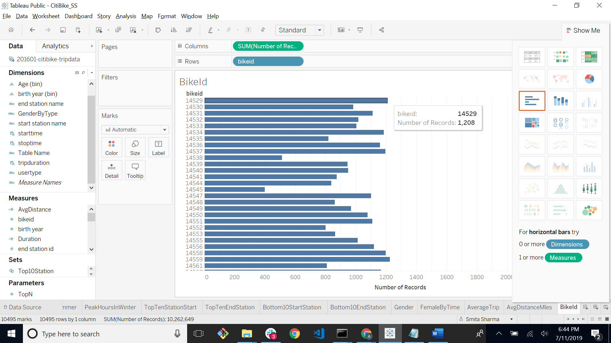

15) A static map that plots all bike stations with a visual indication of the most popular locations to start and end a journey with **zip code data overlaid on top** as shown below,

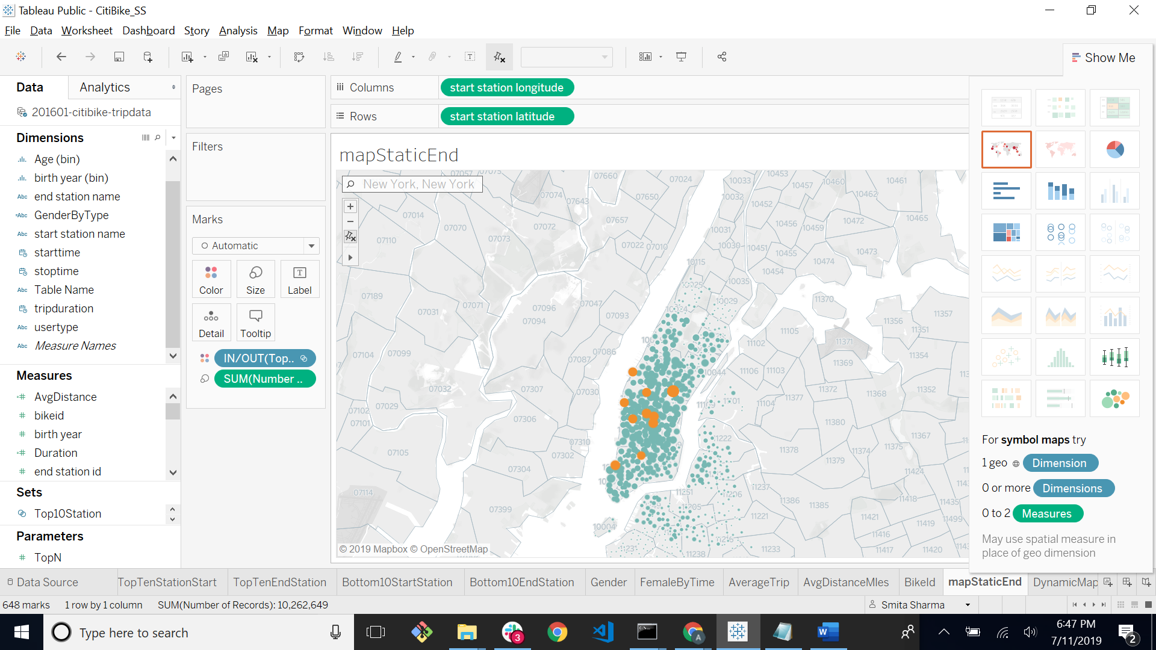

16) If you're working with a merged dataset: a dynamic map that shows how each station's popularity changes over time (by month and year) -- with commentary pointing to any interesting events that may be behind these phenomena.

